Waiting list No.2 Support for 4years
Girl: Suth Reaksa
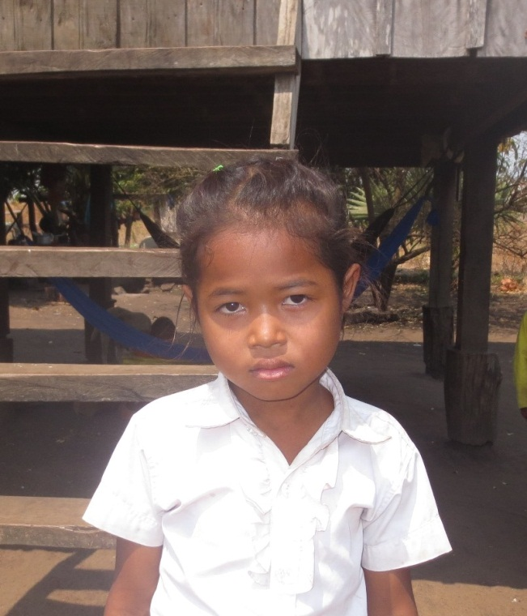
Sponsor’s name:
Suth Reaksa is a 9-year-old student in 3rd grade at Tropheang Chres primary school at Mouy village, Tropheang Chres commune, Khonmom district, Ratanakiri province.
Reaksa has six siblings, five sisters and one brother, and she is sixth child in family. She is orphan whose father died and her mother is a farmer who owns one hectare and half of farmland. The yield of rice is one ton and half per year and it is not enough to feed this 11-member family. So her mother and elder siblings do seasonal works to earn money for food every day. Despite of young age, Reaksa has to help her mother to do housework and to take care of her younger sister.

Date posted:

