Waiting list No.55 Support for 5years
Girl: Hun Sreyneth
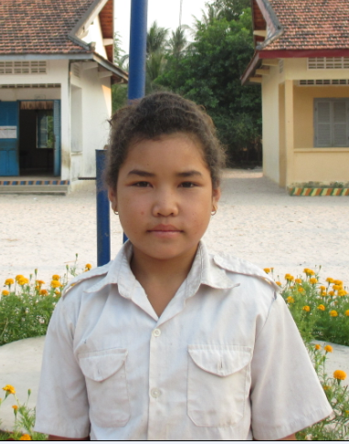

Sponsor’s name:
Hun Sreyneth is an 11-years-old student in 2nd grade at The R.S.Rosenfeld School in Srah Khvav village, Tbeng commune, Banteay Srey district, Siem Reap province.
Sreyneth has three siblings, all are girls, and she is the eldest child in family. Her parents are farmers and they own about one hectare of farmland. Because of limitation of irrigation system, they can grow rice only once a year and the yield is about 1000kg/hectare. Besides farming, her parents work as seasonal workers during rice harvest seasons and cassava harvest seasons. In order to assure three meals per day for family, nowadays her father works as construction worker and he earns $5 per day; and her mother weaves mats every day and she can get $5 per one mat. While her parents are busy to earn money, Sreyneth has to respond to do housework and sometimes she has to find firewood.
Date Posted:

