Waiting list No.28 Support for 3years
Girl: Sambath Mary
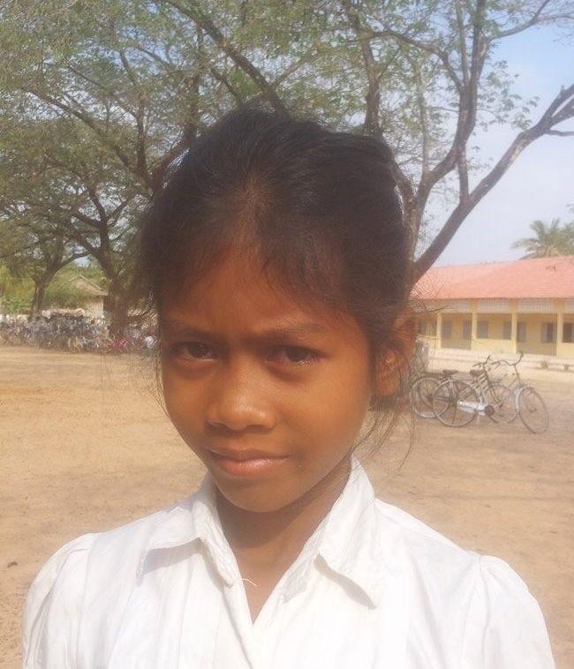

Sponsor’s Name:

Sambath Mary is a 9 years old girl in grade 4 at Vasaskolan school in Angbaksey village, Cheang Torng commune, Tramkak district Takeo province.

Mary has 2 siblings with 2 sisters and she is the first child in the family. There are 4 members in family. Her parents are farmers. They own the 20A of land which produces 650 kg of rice per season. They earn 50$ per month. She helps her parents ‘work after class. In the future, she wants to be a doctor.
Date Post:

