Waiting list No96 Support for 3years
Girl: Samrith Narin
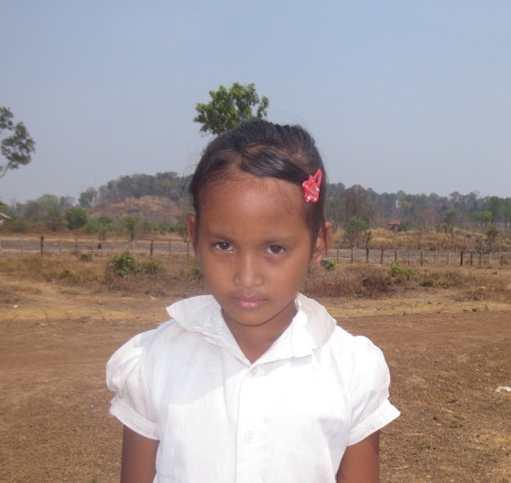
Sponsor’s name:
Samrith Narin is an 11-year-old student in 4th grade at Tropheang chres primary school in Mouy village, Tropheang Chres commune, Khonmom commune, Ratanakiri province.
Narin has two siblings, one sister and one brother, and she is the eldest child in family. Her parents are farmers who own two hectares of farmland. They grow cassava and they get capital money to do farming by borrowing money from micro-finance institute. They have faced a lot of risks such as pest during production and the decrease of cassava price. Narin has to help her mother to do chores in house.

Date posted:

