Waiting list No.53 Support for 3years
Girl: Bun Chanthorn
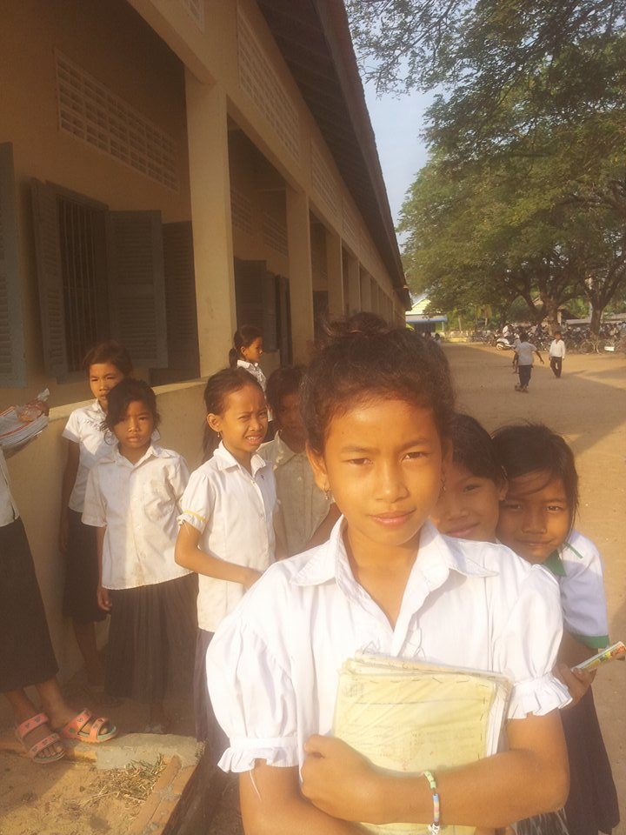

Sponsor’s name:
Bun Chanthorn is an 11 year olds student in grade 4 at Vasaskolan School in Angbaksey village, CheangTorng commune, Tramkak district Takeo province.
Chanthorn has 4 siblings, two brothers and two sisters. She is the second child in the family. There are 6 members in her family. Her father, Mom Chheurn, is a farmer and her mother, Teng Sophal, is a farmer. They live in Angbaksey village, CheangToung commune, Tramkak district, Takeo province. Her parents have 30a of farmland which produces 20 baskets of rice per season. Chanthorn helps to do housework after class. They earn $ 70.00 per month. In the future, she wants to be a teacher.
Date Posted:

