Waiting list No.84 Support for 4years
Girl: Mai Sokchan
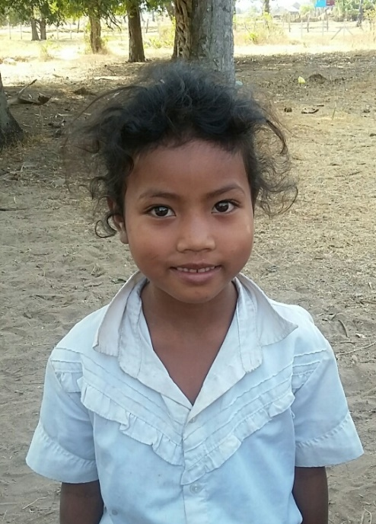
Sponsor’s name:
Mai Sokchan is an 8-year-old student in 3rd grade at The Tokyo-West Rotary Club in Peam Khvav village, Dom Bokroung commune, Phnom Srouch District, Kampong Speu Province.
Sokchan has six siblings, three sisters and three brothers, and she is the youngest child in family. Her father is a farmer who own about a half of one hectare of farmland and the yield of rice farm is about 800kg of rice every year because of lacking of fertilizer and water. Her mother is a mango harvester who earns about $150 per month but this income is according to mango seasons. While her parents and older siblings are busy with farming and other works, Sokchan has to respond to do housework. Those works has forced her to be away from school frequently.
Date posted: February, 2016

