Waiting list No.60 Support for 5years
Girl: Lat Meka
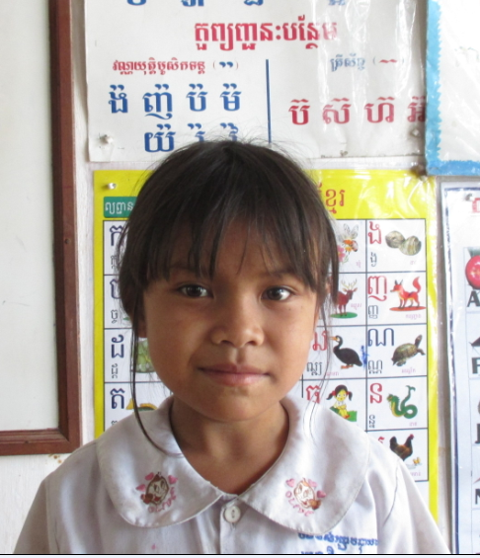

Sponsor’s name:
Lat Meka is a 9 years old student in 2nd grade at The R.S.Rosenfeld School in Srah Khvav village, Tbeng commune, Banteay Srey district, Siem Reap province.
Meka has two siblings, one sister and one brother, and she is the eldest child in family. Her parents are farmers who own about one hectare of farmland, and the rice yield is low because they don’t have money to buy fertilizer and lacking of water, so they get only 700 kg per one hectare. To make balance between income and expense in family, her father works as a construction worker in a pagoda and he earns about $5 per day. Her mother does seasonal works such as planting, harvesting and chopping cassava, and she earns about $3.75-5 per day. While her parents are busy to work outside whole day, Meka has to respond to do housework.
Date Posted:

