Waiting List No.8 Support for 3years
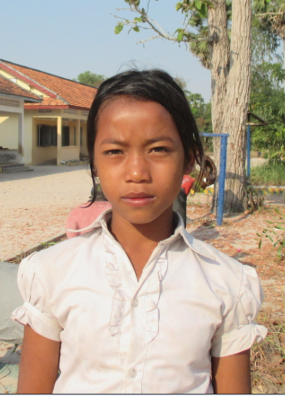
Girl: Lhory Sreysan

Sponsor’s name:
Lhory Sreysan is a 12-year-old student in 4th grade at The R.S.Rosenfeld School in Srah Khvav village, Tbeng commune, Banteay Srey district, Siem Reap province.
Sreysan has nine siblings, six sisters and three brothers, and she is seventh child in family. Her father is in jail because he was charged with domestic violence. Her mother works as a rice seller and her salary is $100 per month. Her elder brothers and sisters cut small trees to sell and they can earn about $5-6.25 per day. While all adults are busy to work out side whole day, Sreysan has to do housework.
Date Posted:

