Waiting list No.46 Support for 3years
Girl: Yen Sreymeth
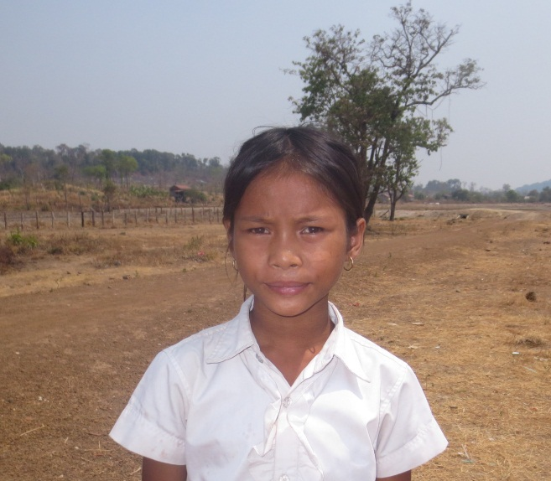
Sponsor’s name:
Yen Sreymeth is an 11-year-old student in 4th grade at Tropheang Chres primary school in Mouy village, Tropheang Chres commune, Khonmom district, Ratanakiri province.
Yen Sreymeth has three siblings, one sister and two brothers, and she is third child in family. Her parents are farmers who own one hectare of farmland. Due to limitation of irrigation system, they can grow rice only one time a year and average yield is 1000-1200kg per hectare. This amount of rice is not enough to feed this family whole year, so her parents do seasonal works such as planting and harvesting cassava, picking cashew nuts, and each of them earns about $3.75-$5 per day but they can work only 2-3 days per week. Sreymeth has to help her parents to do housework while they are busy to work out side whole day.

Date posted:

