Waiting list No.4 Support for 3years
Girl: Chern Kimlang
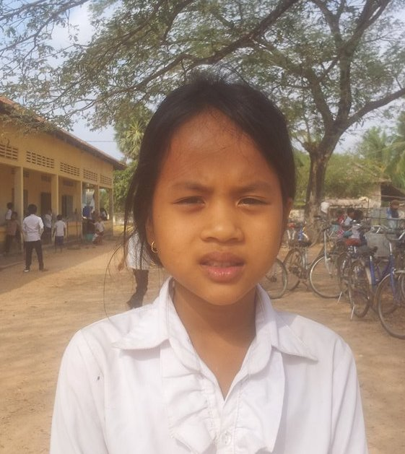

Sponsor’s name:
Chern Kimlang is a 12 years old girl in grade 4 at Vasaskolan School in Angbaksey village, Cheang Torng commune, Tramkak district Takeo province.
Kimlang has 2 siblings with 2 sisters and she is the first child in the family. There are 4 members in family. She lives with her grandmother and grandfather in Prey Chhuer Teal village Popel commune Tramkak district and Takeo province. Her mother and father died when she was baby. Her grandmother and grandfather own the 20A of land which produces 300kg of rice per season. They plant vegetables like water convolvulus and sell for their living. Her grandparents earn 100000 riel per month. She always helps her grandparents ‘work after class. In the future, she wants to be a doctor.
Date Posted:

