Waiting list No.44 Support for 4years
Girl: Ren Sreynuth
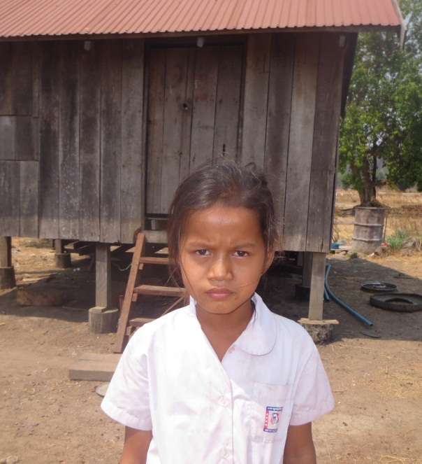
Sponsor’s name:
Ren Sreynuth is an 11-year-old student in 3rd grade at Tropheang Chres primary school in Mouy village, Tropheang Chres commune, Khonmom district, Ratanakiri province.
Sreynuth has one sibling, an elder brother, and she is the youngest child in family. Her parents are farmers and they own half of a hectare of farmland. They can grow rice only in rainy season because their land is in rain-fed area. The yield of rice is 500kg per year and it is not enough for this family. So her parents do seasonal works such as planting and harvesting cassava, picking cashew nuts or clear weeds in farms. Each of them earns about $3.75-$5 per day. As a daughter, Sreynuth has to respond to do housework when her mother is very busy to work out side whole day.

Date posted:

