Waiting list No.29 Support for 4years
Girl: Art Bora
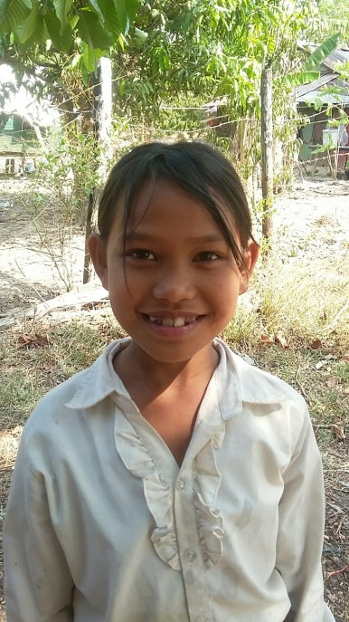
Sponsor’s name:
Art Bora is a 10-year-old student in 3rd grade at The Kirivorn School in Kirivorn village, Steng Chhay communce, Kompong Seila district, Koh Kong province.
Bora has three siblings, one sister and two brothers, and she is second child in family. Her parents search for oysters and shellfishes at sea in Koh Kong province, they can earn about $5-$7 per day. Her father is frequently sick, so her parents don’t have enough ability to support all children to study, so Bora and her siblings live with her grandmother who lives in Kompong Seila district. Her grandmother works as a land guard, her salary is $32.5 per month. In order to earn more money to send her grandchildren to school, she makes some cakes to sell every day and Bora has to bring some cake to sell at her school in the morning before her class starts. Besides this, her grandmother harvests Thatch (a kind of grass) and makes sheets of thatch, she can earn about $45 per year. Despite of her young age, Bora has to help her grandmother to do housework and to sell cakes at school every day.
Date posted:

