Waiting list No.33 Support for 4years
Girl: Chham Sokchen
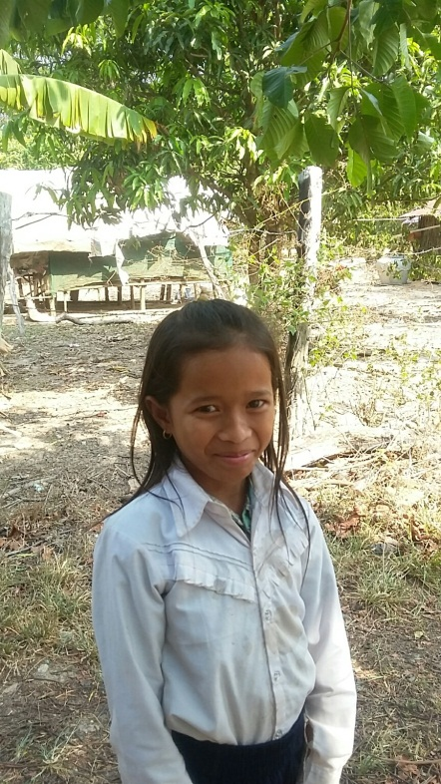
Sponsor’s name:
Chham Sokchen is an 11-year-old student in 3rd grade at The Kirivorn School in Kirivorn village, Steng Chhay commune, Kompong Seila district, Koh Kong province.
Sokchen has five siblings, three sisters and two brothers, and she is third child in family. Her parents are land guards whose salary is $62.5 per month. Besides this job, they grow some vegetables and they cut firewood to sell. Sokchen has to help her mother to do housework and to water vegetables every day before she goes to school.
Date posted:

