Waiting list No.11 Support for 3years
Girl: Phay Sreychen
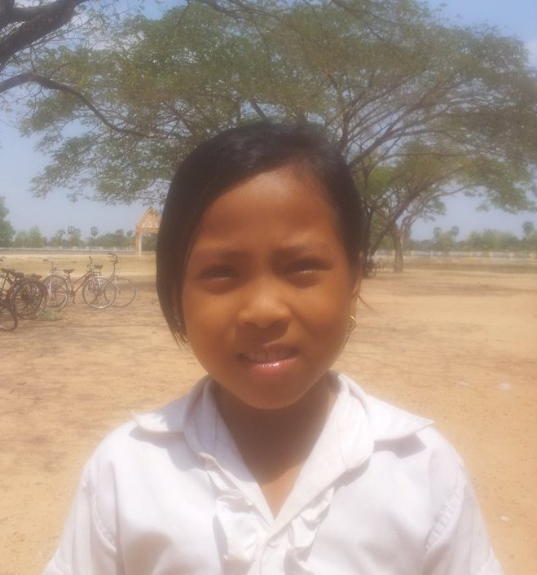

Date Poted:
Sponsor’s name:
Phay Sreychen is a 9 years old girl in grade 4 at Vasaskolan school in Angbaksey village, Cheang Torng commune, Tramkak district Takeo province.
Sreychen has 2 siblings with 1 sister and 2 brothers and she is the second child in the family. She lives in Angbaksey village, Cheang Turng commune Tramkak district, Takeo province. There are 5 members in family. Her mother is a garment factory worker and her father died when she was baby. They own the 20A of land which produces 720kg of rice per season. Her mother earn 100$ per month. She always helps her parent‘s work. In the future, she wants to be a teacher.
Dated Posted:

