Waiting List No.62 Support for 2years
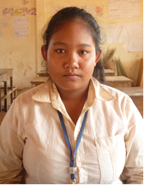
Girl: Yoeurn Solin

Sponsor’s Name:
Yoeurn Solin is a 15-years-old student in 8th grade in The Naohriro Nishiya School in Tbaung Teuk village, Meanrith commune, Sondann district, Kompong Thom province.
Solin has three siblings, two sisters and one brother, and she is the eldest child in family. She is orphan whose father died and her mother is a farmer who owns about two hectare of farmland. She can make profit from farming about $250 per season. Solin has to help her mother to do housework and she also has to work in farm.

Date Posted:

