Waiting List No.43 Support for 5years
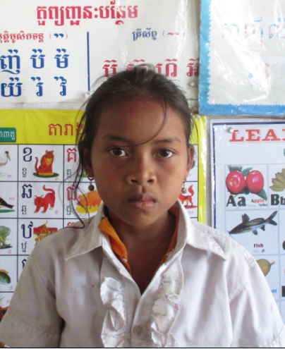
Girl: Moth Reaksa

Sponsor’s name:
Moth Reaksa is a 9-years-old student in 2nd grade at The R.S.Rosenfeld School in Srah Khvav village, Tbeng commune, Banteay Srey district, Siem Reap province.
Reaksa has four siblings, three sisters and one brother, and she is third child in family. Her parents do seasonal works to earn money, these works are harvesting rice and cassava, clearing forest and cutting small trees. They can earn about $3.75-5 per day. Besides those jobs, they go fishing to get fishes for cooking. Reaksa has to respond to chores in house because her parents and elder siblings are busy to work out side whole day.
Date Posted:

