Waiting list No.50 Support for 3years
Girl: Cheurn Sreykim
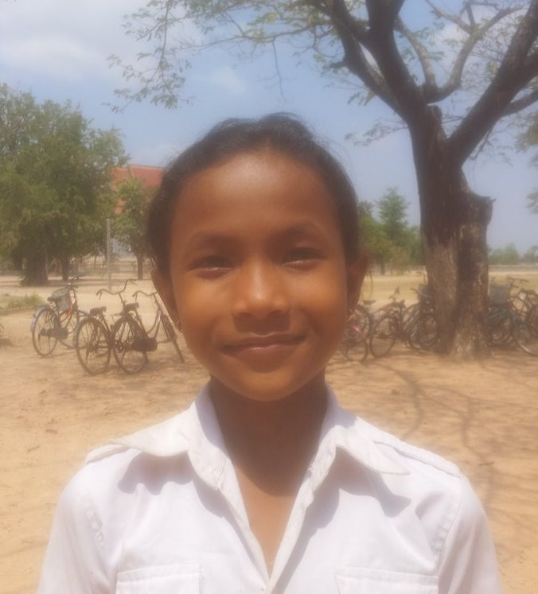

Sponsor’s name:
Cheurn Sreykim is a 11 years old girl in grade 4 at Vasaskolan school in Angbaksey village, Cheang Torng commune, Tramkak district Takeo province.

Sreykim has 3 siblings with 1 brothers and 2 sisters and she is the third child in the family. There are 5 members in family. Her parents are farmers. Her father works as a construction worker occasionally and feeds animals to earn profit for family. They own the 50A of land which produces 1 ton of rice per season. Her parents earn 300000 riel per month. She always helps her parents ‘work after class and reads books. In the future, she wants to be a doctor.
Date Posted:

