Waiting list No.92 Support for 3years
Girl: Khhin Kanha
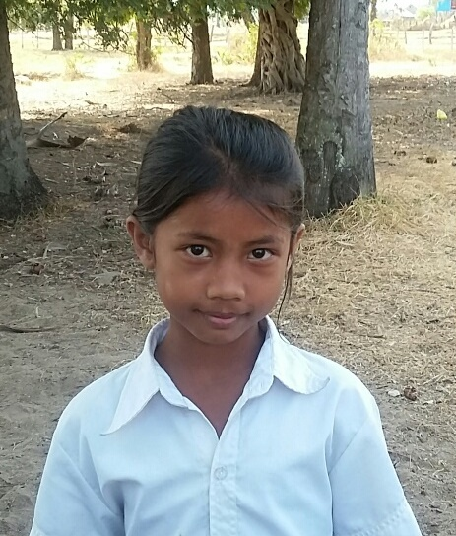
Sponsor’s name:
Khhin Kanha is an 11-year-old student in 4th grade at The Tokyo-West Rotary Club in Peam Khvav village, Dom Bokroung commune, Phnom Srouch District, Kampong Speu Province.
Soary has three siblings, two sisters and one brother, and she is the eldest child in family. Her father is a farmer who own about one ha of farmland. The productivity of their land is very low due to the lack of water supply, so their rice yield is only 1200kg of rice per year. Her mother is a garment factory worker and her salary is $150 per month. Her parents are very busy to work outside of house whole day, hence despite of young age, Soary has to respond to do housework and to take care of her younger siblings. Those responsibility has forced her to be absent from school frequently.
Date posted: February, 2016

