Waiting list No82 Support for 4years
Girl: Boeurn Phymean
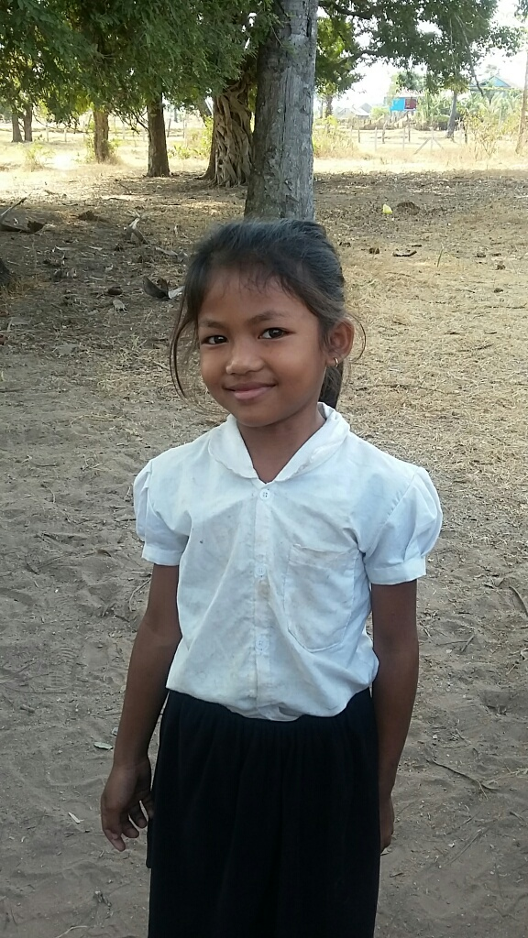

Sponsor’s name:
Boeurn Phymean is a 10-year-old student in 3rd grade at The Tokyo-West Rotary Club in Peam Khvav village, Dom Bokroung commune, Phnom Srouch District, Kampong Speu Province.
Phymean has three siblings, all are girls, and she is the eldest child in family. Her father is a house construction worker who earns about $160 per month but it is not regular work. Her mother stays at home. This family owns about a half of one hectare of farmland. They grow rice every year but their farm is in rain-fed area, so the yield is low, about 800kg of rice every year. Phymean has to help her mother to do housework, so she is absent from school very often especially during farming season.
Date posted: February, 2016

