Waiting list No51 Support for 2years
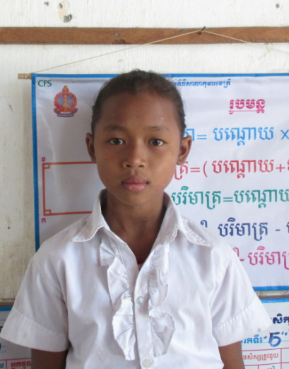
Girl: Phea Isou

Sponsor’s name:
Phea Isou is an 11-years-old student in 5th grade at The R.S.Rosenfeld School in Srah Khvav village, Tbeng commune, Banteay Srey district, Siem Reap province.
Isou has three siblings, two sisters and one brother, and she is second child in family. Her parents are famers who own one hectare of farmland and their rice yield is about one ton per hectare because of limitation of water. The income from farming is not enough, so her father works as construction worker at a pagoda and he earns $5.00 a day. Her mother weaves a kind of Khmer traditional carrier (La Ie) and she gets $3.37 or $5 per one carrier, according to its size. One carrier can exchange with 10-15 kg of rice. While her parents are busy to work whole day, Isou has to respond to do housework.
Date Posted:

