Waiting list No.45 Support for 4years
Girl: Phel Sreypov
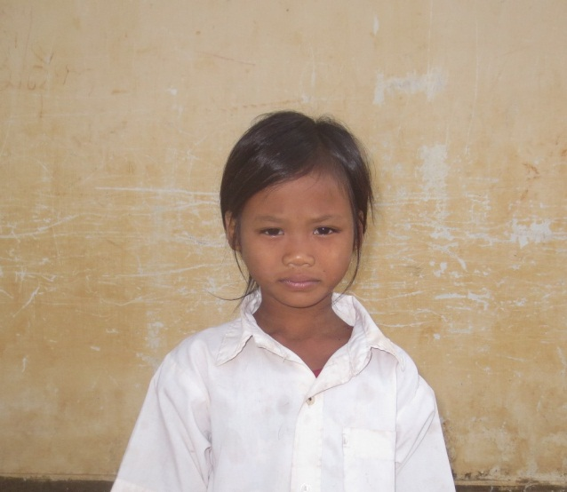
Sponsor’s name:
Phel Sreypov is a 9-year-old student in 3rd grade at Tropheang Chres primary school in Mouy village, Tropheang Chres commune, Khonmom district, Ratanakiri province.
Sreypov has two siblings, all are sisters, and she is third child in family. Sreypov is an orphan whose father has died since she was young. Her mother is a farmer who owns half of one hectare of farmland. She grows soybean but she didn’t make any profit and lost a lot of money this year because the price of soybean has been decreased. In order to have three meals per day for her children, she works as a seasonal worker and she earns about $3.75-$5 per day, but it is not a permanent income of this family. Sreypov has to help her mother to do housework and sometimes, she claim Tamarin tree to pick young leaves to sell and she earn about $0.1 each time.

Date posted:

