Waiting list No.71 Support for 5years
Girl: Chhoeng Sreynoch
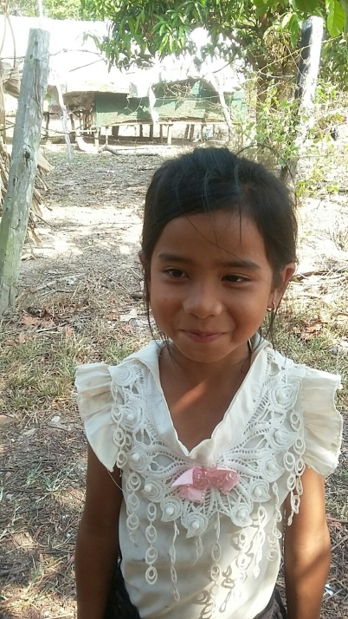
Sponsor’s name:
Chhoeng Sreynoch is an 8-year-old student in 2nd grade at The Kirivorn School in Kirivorn village, Steng Chhay commune, Kompong Seila district, Koh Kong province.
Sreynoch has four siblings, two sisters and two brothers, and she is the youngest child in family. Her parents raise chickens and buffaloes. Besides this work, they cut firewood to sell every day. Their income is about $100 per month. Sreynoch has to help her mother to do housework and to take care of chicken, when her parents are away from house.
Date posted:

