Waiting list No.42 Support for 4years
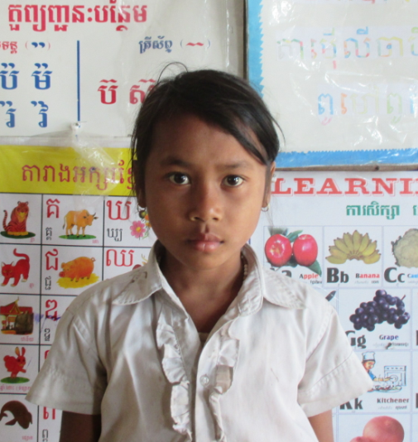
Girl: I Sreymao

Sponsor’s name:
I Sreymao is an 11-year-old student in 3th grade at The R.S.Rosenfeld School in Srah Khvav village, Tbeng commune, Banteay Srey district, Siem Reap province
Sreymao has one sibling, a younger sister, and she is the eldest child in family. Her parents have been divorced for eleven years. Her father has remarried and he has never sent any allowance to her. Her mother doesn’t want to remarry because she is afraid that her step-husband may persecute her children. She doesn’t own any farmland, so she weaves a kind of Khmer traditional carrier (La Ie). She can get about $3.75-5 per one carrier, according to its size, and one carrier can exchange with 10 kg of rice. Sreymao has to help her mother to do chores in house and finds firewood.
Date Posted:

