Waiting list No.37 Support for 4years
Girl: Nop Navid
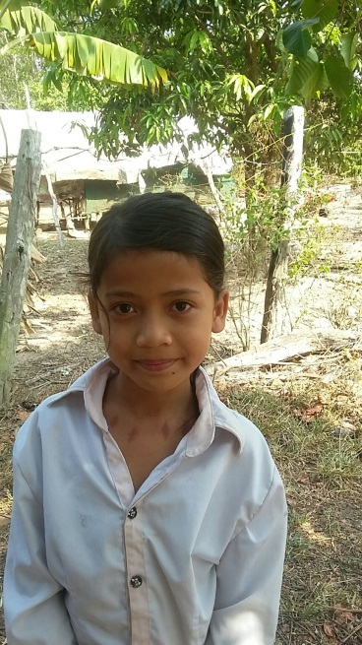
Sponsor’s name:
Nop Navid is a 9-year-old student in 3rd grade at The Kirivorn School in Kirivorn village, Steng Chhay communce, Kompong Seila district, Koh Kong province.
Sreyvid has seven siblings, three sisters and four brothers, and she is the youngest child in family. Her parents are farmers who own about one hectare of farmland and the yield of rice farming is about 1-1.5 ton/hectare. Profit from rice farming is not enough to feed this big family, so her mother sells groceries at home and she can earn about $2.5-$3.75 per day. Sreyvid has to help her mother to do housework and sell groceries at home when her parents are busy in rice field.
Date posted:

