Waiting List No.58 Support for 3years
Girl: Khum Sokna
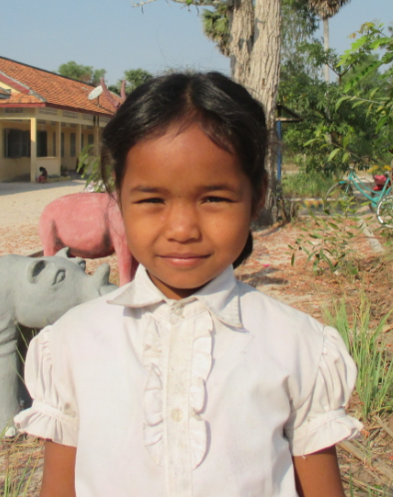

Sponsor’s name:
Khum Sokna is a 10-year-old student in 4th grade at The R.S.Rosenfeld School in Srah Khvav village, Tbeng commune, Banteay Srey district, Siem Reap province.
Sokna has four siblings, three sisters and one brother, and she is third child in family. Her parents are farmer who own one hectare of farmland and the yield of rice is about 1.5 ton per hectare. To earn more money, her parents do seasonal works such as harvest rice, clear forest and harvest cassava; all these works provide about $3.75-5 per day. Besides those works, they go fishing to get fishes for cooking and pick some vegetables to sell. Presently, her father immigrates to work in Siem Reap province as a cassava harvester and he send his family about $3.75 per month. With absence of her father, Sokna has to help her mother to do housework, find firewood and water crops.
Date Posted:

