Waiting list No.57 Support for 3years
Girl: Toem Sreynoch
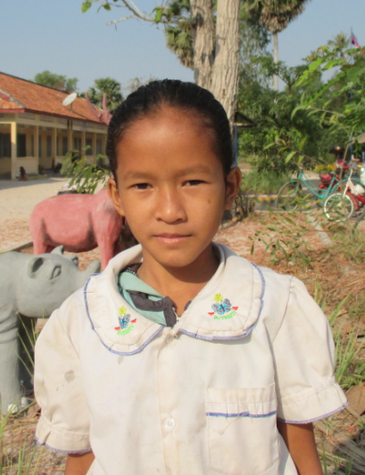

Sponsor’s name:
Toem Sreynoch is a 10-years-old student in 4th grade at The R.S.Rosenfeld School in Srah Khvav village, Tbeng commune, Banteay Srey district, Siem Reap province.
Sreynoch has three siblings, two sisters and one brother, and she is the eldest child in family. Her parents are seasonal workers. Her father works as a construction worker at a pagoda and he earns $5 per day. Her mother cuts small trees, plants, harvests and chops cassava, and she earns about $3.75-5 per day. Sreynoch has to help her mother to do chores in house and to take care of her younger siblings.
Date Posted:

