Waiting list No.47 Support for 3years
Girl: Nov Sreysor
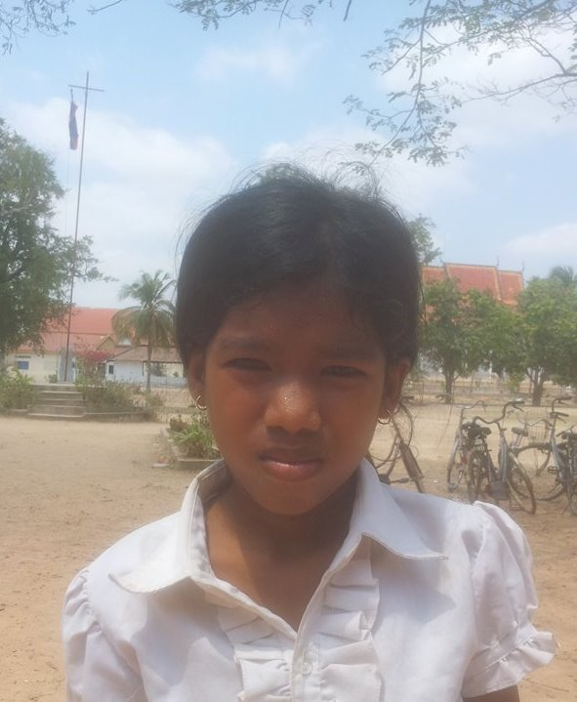

Sponsor’s name:
Nov Sreysor is a 11 years old girl in grade 4 at Vasaskolan school in Angbaksey village, Cheang Torng commune, Tramkak district Takeo province.
Sreysor has 5 siblings with 3 brothers and 2sisters and she is the fourth child in the family. There are 7 members in family. Her parents are farmers. They own the 30A of land which produces 15 baskets of rice per season. Her parents earn 250000 riel per month. She always helps her parents ‘work after class and likes reading books. In the future, she wants to be a teacher.
Date Posted:

