Waiting list No.12 Support for 4years
Girl: South Lab
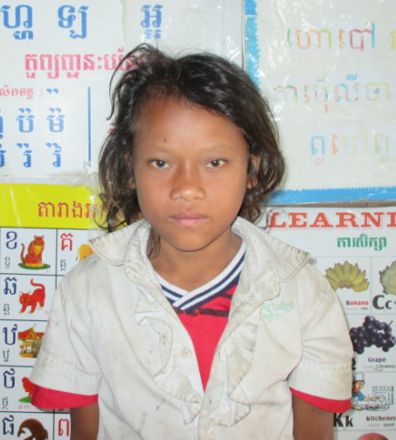

Sponsor’s name:
South Lab is a 9-years-old student in 3rd grade grade at The R.S.Rosenfeld School in Srah Khvav village, Tbeng commune, Banteay Srey district, Siem Reap province.
Lab has three siblings, two sisters and one brother, and she is second child in family. Lab is an orphan whose father died because of an accident when he went to forest to pick wild Lychee to sell, there is a big rock fell on him. Her mother is a seasonal worker; she cuts small trees, plants, harvests and chops cassava. She earns about $3.75-5 per day. Her elder brother works as a construction worker and he earns $5 per day. Lab has to help her mother to do housework.
Date Posted:

