Waiting list No.40 Support for 4years
Girl: Tha Phalla
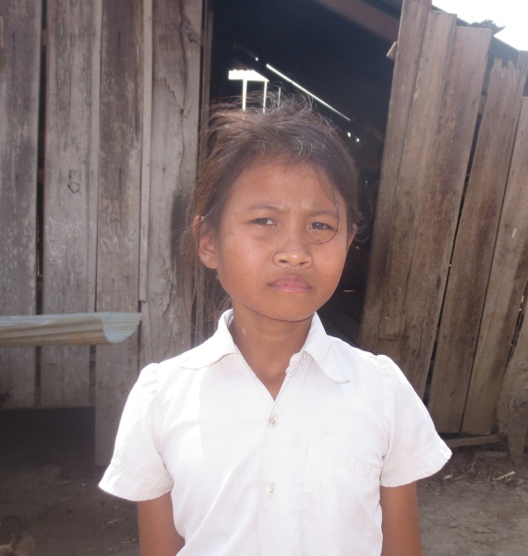
Sponsor’s name:
Tha Phalla is a 13-year-old student in 3rd grade at Tropheang Chres primary school in Mouy village, Tropheang Chres commune, Khonmom district, Ratanakiri province.
Phalla has two siblings, one sister and one brother, and she is the eldest child in family. Her parents are farmers and they own half of one hectare of farmland. Due to lacking of capital and irrigation system, their rice yield is just 400-500kg per year, which is small amount to feed this family for whole year. Besides farming, her father goes hunting in forest every day to earn more money for buying rice and food for family. As a eldest daughter, Phalla has to respond to do housework and to take care of her younger siblings.

Date posted:

